- Table Creation
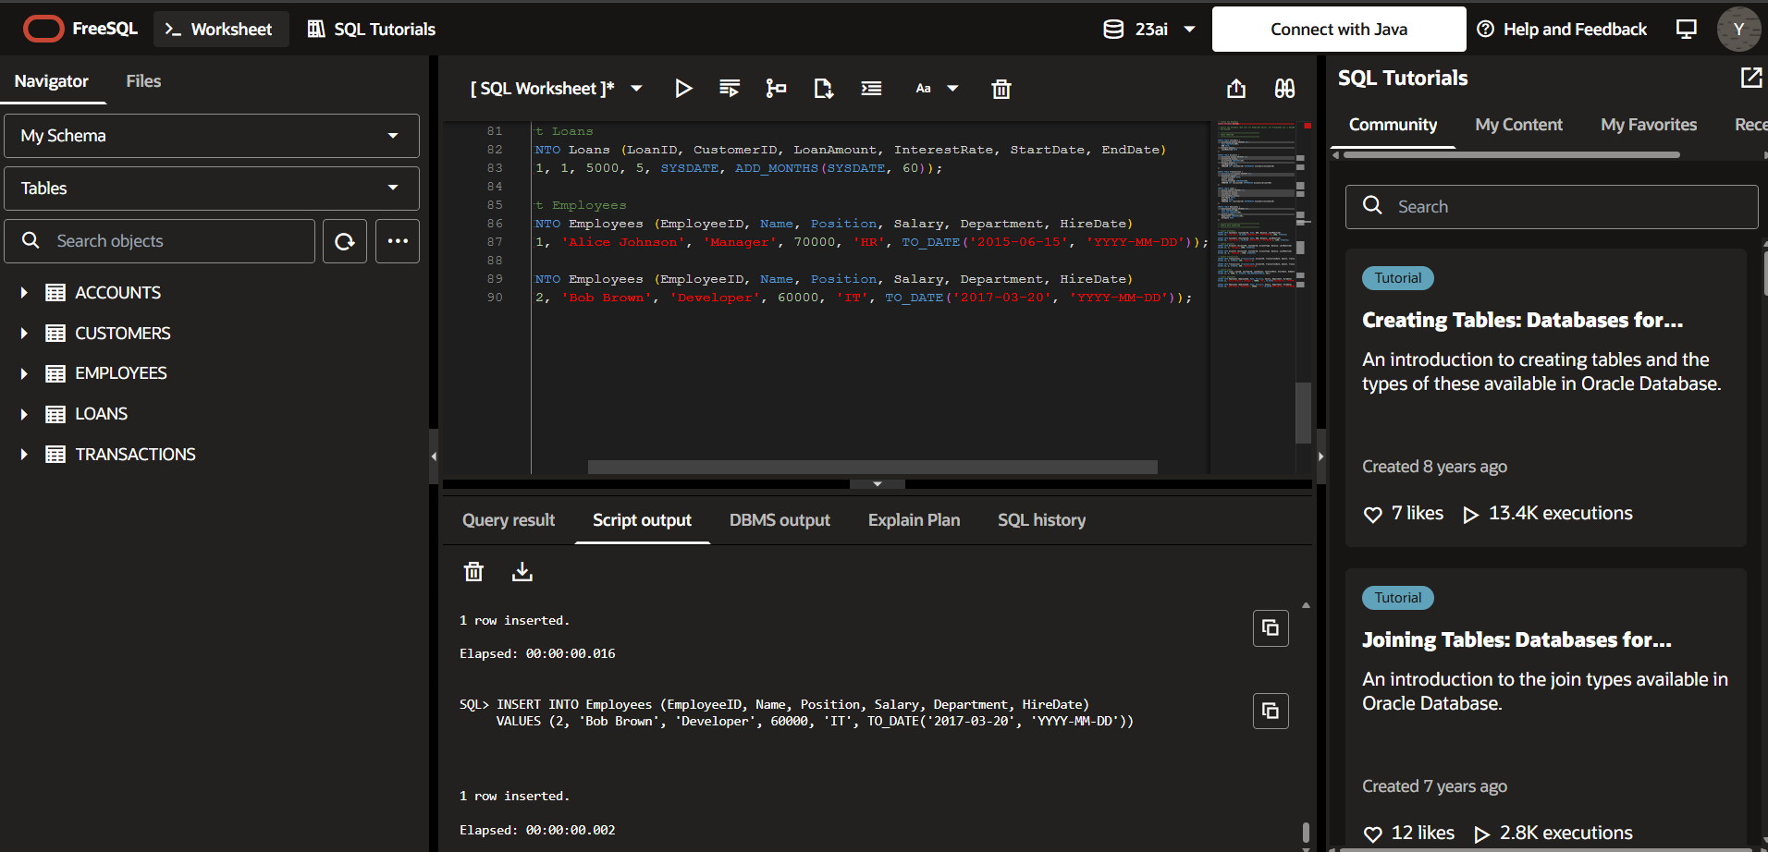
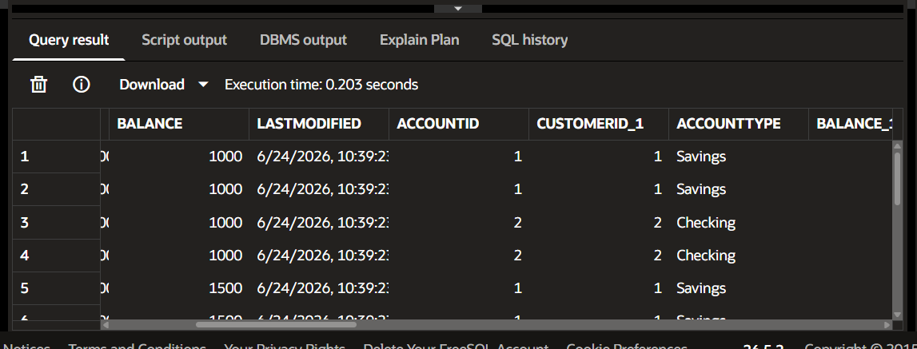
Exercise 1: Control Structures
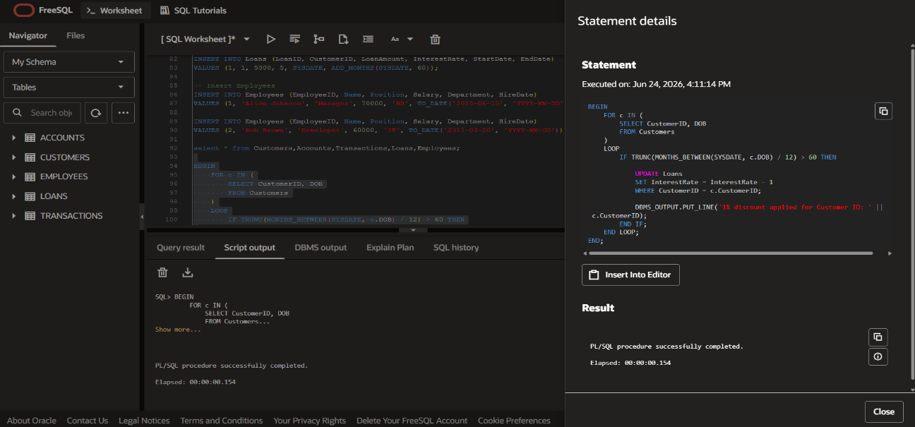
Scenario 1: Age above 60, loan interest 1% discount

Scenario 2: Balance over 10000 then VIP
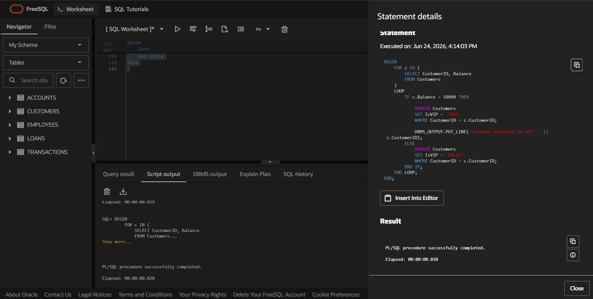
Scenario 3: Loan due within next 30 days
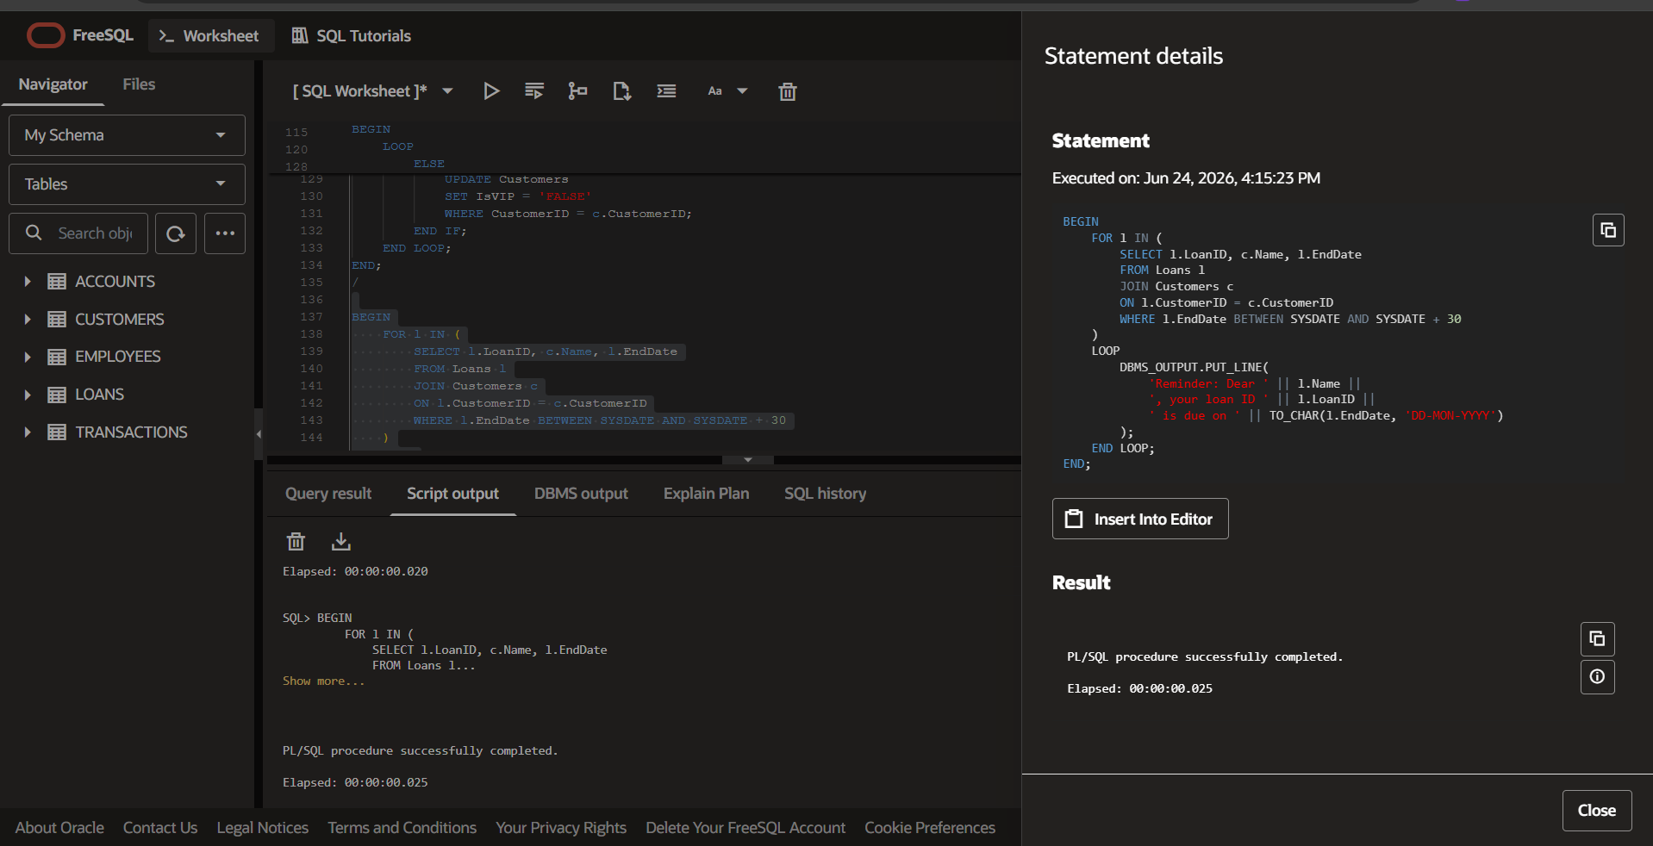

Exercise 3: Stored Procedures
Scenario 1: Process Monthly Interest
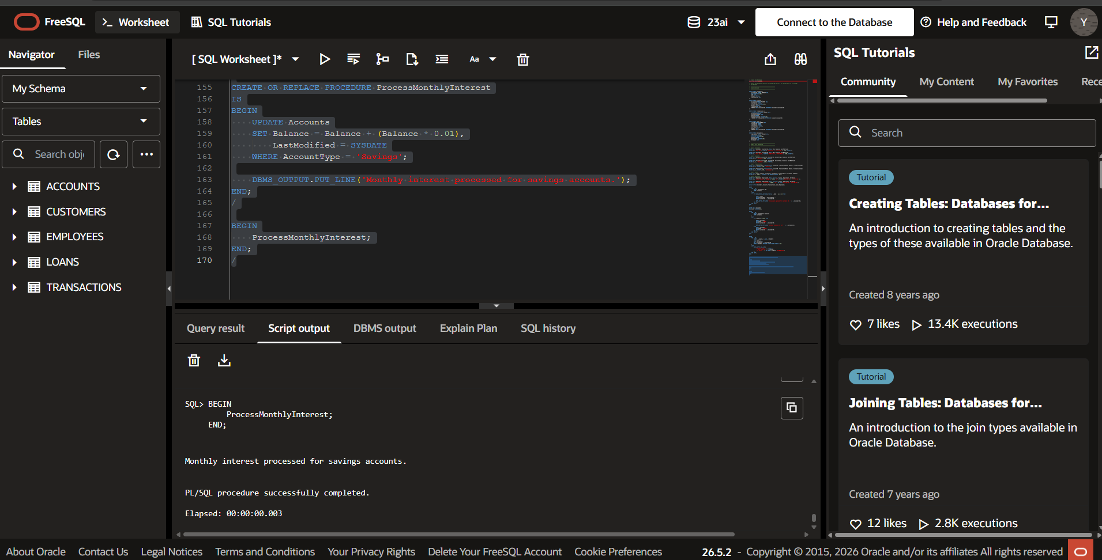
Scenario 2: Update Employee Bonus
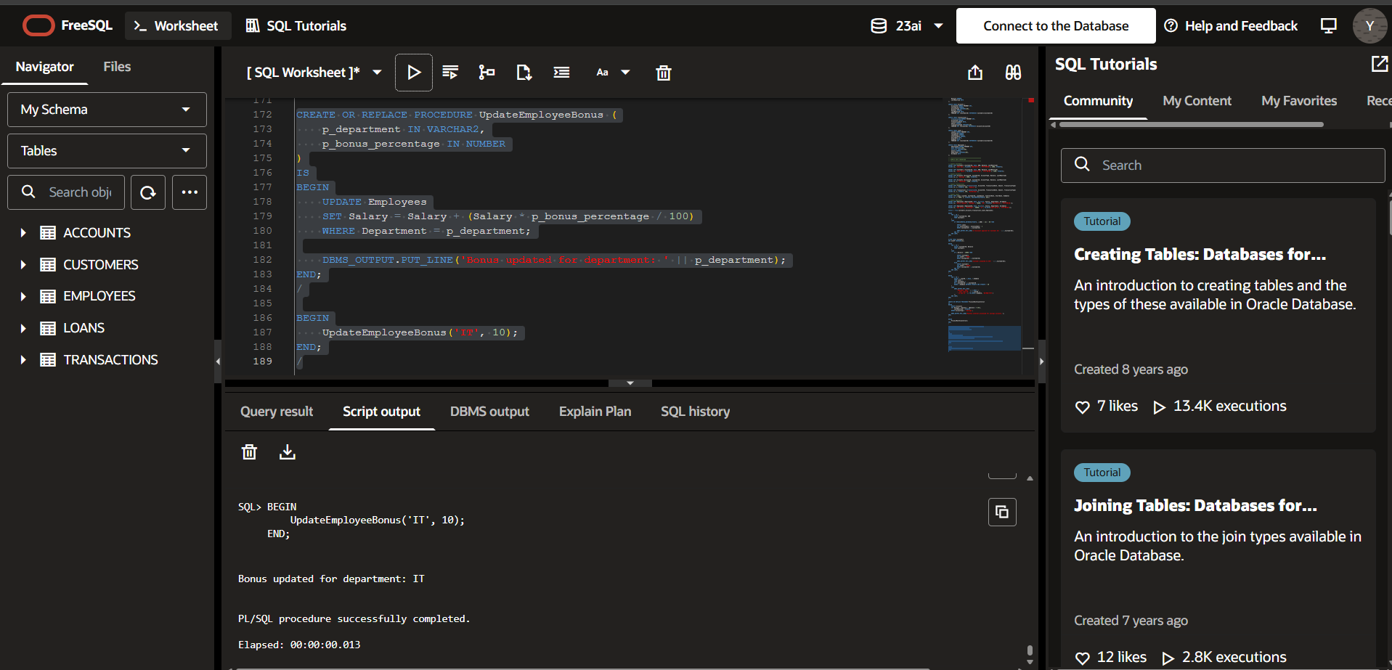

Scenario 3: Transfer Funds
